Maffra Golf Club Inc.

ABN : 44 712 580 577

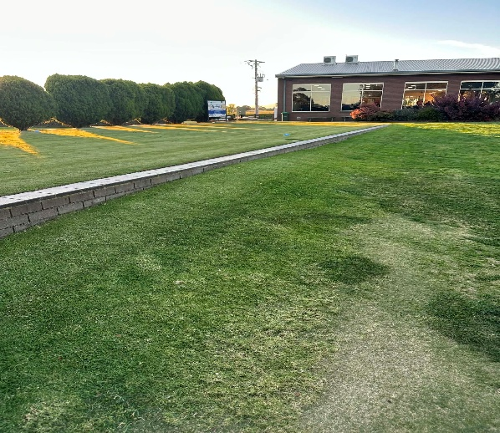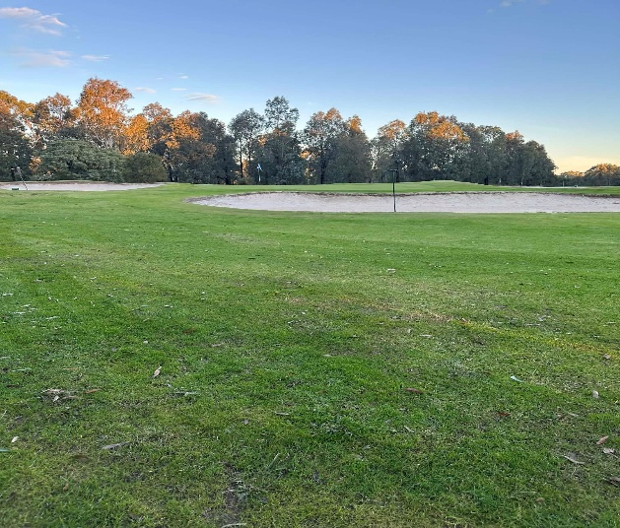

“Tee to Green”

Issue 1 - July 2026

Welcome to the first edition of our Club’s newsletter “Tee to Green”.

The newsletter will be issued following each monthly Committee of Management meeting. A hardcopy will be available in the Clubroom and “links” to the newsletter will be available via “In-Focus”, our Facebook and Web sites thus giving four avenues of communication within the Club.
The overall aim of the newsletter is to provide regular updates on key events and activities within the Club – it will not be advertising daily/monthly golf competitions/events as these are detailed in the Annual Program Booklet issued to all members (available on request from the Bar) and our Booking Sheet via the MGC Website.
Likewise daily golf results will not be published as they are available on our website.
Your COM encourages members to contribute to the newsletter via photos taken on competition days or during presentations and welcomes any feedback regarding content.

FEATURE ARTICLE

“ Making his debut at the 2050 Masters please welcome
to Augusta from Australia, Cooper Rimington.”

This is the dream of one of Maffra Golf Club’s up and coming young golfers Cooper Rimington.

Cooper took up golf in earnest at the age of 11 with an initial handicap of 36 however over the last 5 years (now 16) this has rapidly improved to 0.5.
Along the way Cooper has competed in many local tournaments being multiple Junior Champion at Maffra, winner of the Lonsdale Links Junior Open and is about to compete in the Victorian Junior Amateur Championships.
Junior coaches including Matt Portelli and Richard Cooney have assisted in the development of Cooper’s easy going but very potent swing technique. Many members have noted Cooper’s calmness, control and ability to return excellent scores on all courses in the Gippsland Region. Cooper features regularly in team events throughout Gippsland and Pennant - Division 1.
Once Cooper graduates from school with his VCE, he wants to seriously pursue a professional golf career and attributes his dreams, in part, to his father’s long-term involvement in golf – Craig being a 1.9 handicapper and Course Superintendent at Bairnsdale Golf Club.
Cooper foresees a lifetime involvement in the golf industry either via a professional, coach or greenskeeper.
Quick Response Answers
Brand of Clubs – Srixon/Golf Balls -Srixon/Golf Idols – Jason Day & Jake Knapp
Biggest Influence – Mum & Dad Biggest Dream – to be a Professional Golfer
Thanks Cooper and on behalf of the Committee and all members at Maffra Golf Club we wish you every success in your future golfing pursuits.
*******

Course Maintenance Report
Scotty & Billy are supported by a dedicated group of volunteers who continue to maintain our course in fantastic condition - Thankyou.
Tree management is a continuing issue for our Club, due in part to the success of our recently installed watering system.
Trees which have been identified as dangerous, causing obstruction or have just gone beyond their lifespan have small flags attached indicating removal at a later date.
Several options are being considered and a number of quotes have been received however, no matter which option is chosen, this will be an expensive exercise.
Scotty and your COM are monitoring this sensitive issue and hope to have “a plan of action” shortly.

Currently our course looks magnificent and many favorable comments are being received from visiting golfers.
PLEASE continue to repair yours and any pitch marks you come across on our greens as well as filling divots and raking bunkers – “many hands make light work”.

*** APPEAL TO ALL MEMBERS ***

Recently significant damage has occurred around some garden beds and greens caused, we believe, by green fee players and a number of “juniors”. If you witness such behaviour you, as a member, have the right to question those involved and report the circumstances to a Committee member so as appropriate action can (and will) be taken.
Ian Templeton

Social Report

Friday Nights
Every Friday commencing at 4.30pm members and RV Park visitors meet in the Clubroom for a social gathering which includes a Members Draw (member must be present to win), the 100 Club draw (when complete) and a raffle. All members are encouraged to attend.

Advance Notice – MGC 75th Anniversary Celebration
This is an important event on our 2026 calendar and marks the 75TH Anniversary of Maffra Golf Club at our Fulton Road home. We are celebrating this milestone commencing on Sunday 22nd November at the Sale Greyhounds where we will be sponsoring 10 races. This will be followed by a “Weekend of Golf” on 28th (BBQ & golf) & 29th November (golf & Anniversary Luncheon). A sub-committee is co-ordinating the weekend – more details to follow.

“Long Table” Report
The “Long Table” has been running each Wednesday, following the men’s daily event, for over 20 years. Primarily it is a social group teeing off around 11am and then getting together for refreshments about 3.30pm where daily winners are declared (best front & back nine/best overall), “wagers” are settled and good hearted banter abounds.

However the “Long Table” is much more than it first appears. Over its history the “Long Table” has made substantial financial contributions to our Club for specific projects including practice nets, pathways, a Clubhouse TV and the latest being the updating of our “Honour Boards” in gold leaf.

On behalf of all MGC members Thankyou.

All men who play regularly each Wednesday are eligible to join the group following nomination and playing three Qualifying Rounds. Contact : Molly 0427 609 365

Photo Highlights
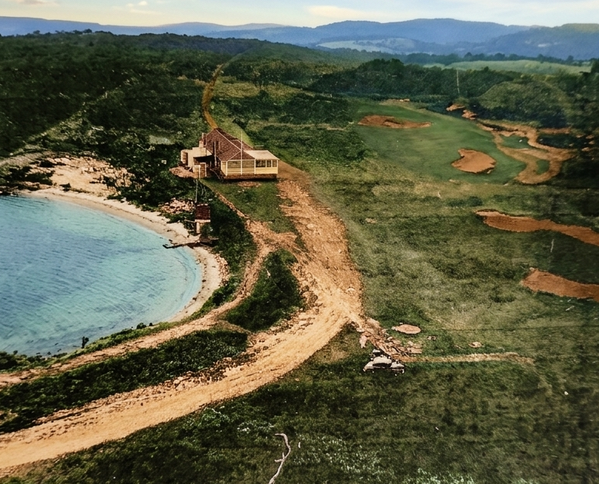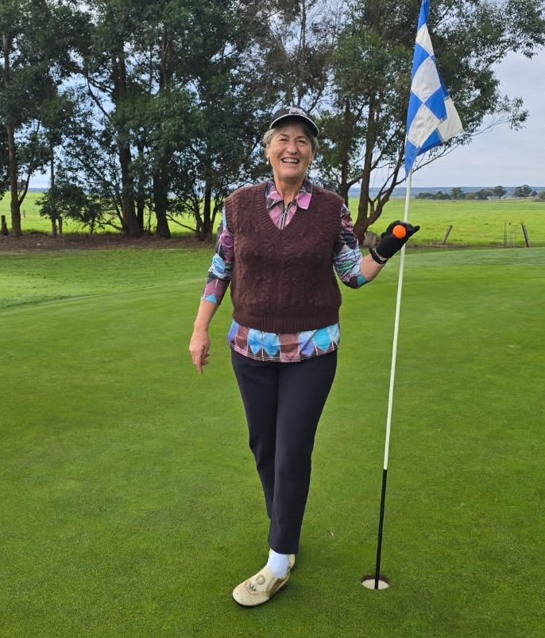
What a difference 75 years makes ! Mandy – Hole in One 2nd

Committee Notes
New Members
At our June meeting your Committee welcomed Balin Powell as a Junior Comp member.

Strategic Plan
An email was sent to all members 15/05 regarding the next MGC 5 Year Strategic Plan - members are encouraged to read the document and complete the priority section & suggest any other projects so that a comprehensive plan can be produced for the guidance of future Committees of Management.
A tray is placed on the bar for completed forms - Thankyou.

Committee Participation
Do you realise that most of our current Committee members are over 70 yo ? The future of your Club revolves, in part, around a solid, active and dedicated Committee. At each Annual General Meeting a new Committee is elected. Our younger members are the future of our Club and the Committee encourages your participation in planning for that future via your involvement in our Committee.
Enquiries can be made via Alex Johnson (0477 662 000) or Barry Nicholl (0408 324 377).

Annual General Meeting
Our 2025/2026 AGM will be held on Friday 2nd October commencing at 6.00pm and will be followed by our Friday night social gathering. Agenda, Financial and General Reports will be circulated prior to the AGM.
All members are invited to attend and nominate for vacant COM positions.

Sponsors Day
The Committee is planning to have a “Sponsors Day” on Friday 23rd October 2026. Sponsors will be invited to have an afternoon round of golf followed by our normal Friday Night social gathering. A “Special Sponsors Raffle” will be held and members are invited to participate in the event to assist the Club in thanking our many loyal Sponsors.

Clubroom Hiring
Our Clubroom is available for hiring to Members of MGC for Corporate Golf Days, business networking events or family celebrations – enquiries welcome via Fay (0417 055 612)

Newsletter Editor Jim - Email : sandman2001@bigpond.com

MGC Contact Details
Course Address : Fulton Road, Maffra Clubhouse : 5147 1884
Postal : PO Box 81 Maffra 3860 Email : admin@golfmaffra.com.au

MAFFRA GOLF CLUB – THANKYOU TO OUR VALUED SPONSORS


















